PROJECT STAGE 1 - REPORT

UNIT: COMP5310 - Principles of Data Science

GROUP NO.: Lab014_Group_04

SID of Members | UniKey
560244999 | bkon0083
550615055 | isar0627
560457821 | rsel0893

Table of Contents

Section | Title | Page
Dataset A: NSW Train Occupancy
Step 1 | Problem Definition | 3
Step 2 | Data Description | 4
Step 3 | Data Cleaning and Processing | 5
Step 4 | Exploratory Data Analysis | 6
Dataset B: Air Travel Delay
Step 1 | Problem Definition | 11
Step 2 | Data Description | 12
Step 3 | Data Cleaning and Processing | 14
Step 4 | Exploratory Data Analysis | 18
Dataset C: Hotel Booking
Step 1 | Problem Definition | 23
Step 2 | Data Description | 27
Step 3 | Data Cleaning and Processing | 29
Step 4 | Exploratory Data Analysis | 34

Dataset A: NSW Train Occupancy

Step 1. Problem Definition

1.1 Business Problem
The NSW train network provides services to hundreds of thousands of passengers on a daily basis, yet a real-time insight about crowding in trains remains a challenge for both the operators and the passengers alike. This analysis defines the following classification problem:

"Is it possible to predict a train’s occupancy status based on features such as route direction, station sequence number, service line and time of day?”

1.2 Stakeholders and Benefits

Stakeholder | Benefit from Solving the Problem
Transport for NSW | Optimize train scheduling so that additional services can be deployed during peak hours.
Commuters | Will be able to plan less crowded journeys and save time.
City Planners | Understand peak demand patterns to improve infrastructure decisions.
Station Managers | Proactively manage platform services to avoid crowding and support good passenger flow.

1.3 Problem Type
This problem statement can be modelled as a classification problem. The target variable being Occupancy Status, a categorical variable with three classes: MANY_SEATS_AVAILABLE, FEW_SEATS_AVAILABLE, and STANDING_ROOM_ONLY. The goal is to predict which category a given train service falls into based on its route, direction, and temporal features.

Step 2. Data Description

2.1 Dataset Overview
The NSW Train Occupancy dataset was loaded and inspected to understand its structure and content before any cleaning was applied to the dataset.

Property | Value
Total Rows (instances) | 50,250
Total Columns (attributes) | 14
Missing Values | Present (dropped during cleaning)
Duplicate Rows | Present (removed during cleaning)

2.2 Data Types of Each Attribute
Attribute | Data Type | Description
day | int64 | Calendar day of the recorded service
Node.Seq.Order | int64 | Station sequence position within the route
Occupancy Status | object (categorical) | Crowding level: MANY_SEATS_AVAILABLE, FEW_SEATS_AVAILABLE, STANDING_ROOM_ONLY
Segment.Direction | object (categorical) | Direction of travel: Up or Down
Service.Line | object (categorical) | Name of the train service line
Other columns | object / int64 | Station names, origin/destination, train type, service identifiers.

2.3 Missing Values and Duplicates
An initial inspection using df.isnull().sum() and df.duplicated().sum() revealed the presence of both missing values and duplicate rows. The exact counts are detailed below:

Issue | Finding | Action Taken
Missing Values | Present across multiple columns | Rows with missing values dropped using df.dropna()
Duplicate Rows | Duplicate entries detected | Removed using df.drop_duplicates()
Rows after Cleaning | Reduced from 50,250 | Final shape verified after cleaning

2.4 Unique Values in Categorical Features
Key categorical columns were inspected for unique values. This revealed data quality issues that are addressed in Step 3:
- Occupancy Status: Initially showed inconsistent entries including 'MANY_SEATSAVAILABLE' (missing underscore) and 'VTANDING_ROOM_ONLY' (typographical error).
- Segment.Direction: When analyzed it was found that it had 4 unique values in the raw data when in reality only 2 directions existed in the dataset. Turned out the issue was caused due to trailing whitespaces in (“Up” and “Down”).
- Service.Line: Multiple train service lines are present across the NSW train network.

Step 3. Data Cleaning and Processing

3.1 Issues Identified and Cleaning Strategies
The following data quality issues were identified and resolved using data cleaning strategies.
“Some issues (in Occupancy Status & Segment.Direction) were discovered iteratively during EDA and fixed retroactively, as noted in the notebook.”

Issue | Column Affected | Cleaning Strategy | Justification
Missing values | Multiple columns | Dropped rows using df.dropna() | Rows with missing values cannot be reliably imputed with values without domain knowledge. Removal of such rows ensures data integrity.
Duplicate rows | Entire dataset | Removed using df.drop_duplicates() | Duplicates would skew frequency counts and introduce bias in EDA and modelling.
Inconsistent capitalization | Occupancy Status | Standardised to uppercase using str.upper() | Ensures consistent category labels for grouping and visualization.
Missing underscore typo | Occupancy Status ('MANY_SEATSAVAILABLE') | Replaced using df.replace() | Corrects the label to match the valid category MANY_SEATS_AVAILABLE
Typographical error | Occupancy Status ('VTANDING_ROOM_ONLY') | Replaced using df.replace() | Corrects the label to match the valid category STANDING_ROOM_ONLY
Trailing whitespace | Segment.Direction | Stripped using str.strip() | Trailing spaces caused Up and Down to appear as 4 distinct categories instead of 2.

Insight on missing and duplicate values: Upon thorough inspection of the dataset, the total missing values and duplicate rows were calculated to be 522 and 250.

This implies approximately 49,478 rows are expected after cleaning. However, the actual count came out to 49,482 rows, suggesting some rows had both missing values and duplicates simultaneously.

3.2 Data After Cleaning
After applying all cleaning processes, the dataset was verified and saved as train_occupancy_cleaned.csv. The final cleaned dataset had no missing values, no duplicate rows, and ready for EDA and future modelling in Stage 2. However, note: some issues were discovered during EDA (please refer to section 3.1 for more information).

Step 4. Exploratory Data Analysis
Four features were selected for EDA, two categorical attributes (Occupancy Status, Segment.Direction) and two numerical attributes (Node.Seq.Order, day). These were chosen because of their direct relevance to the research question defined in Step 1.

NOTE: Initially Service.Line attribute was considered for categorical feature 2, but due to the presence of a huge spectrum of unique categorical values for the attribute, Segment.Direction seemed to be a better option than Service.Line attribute since it only had 2 unique values upon cleaning of the trailing whitespaces in its values.

4.1 Categorical Feature 1: Occupancy Status
A bar chart was used to visualize the distribution of occupancy categories, as bar charts are the standard method for comparing frequencies across distinct categorical groups.

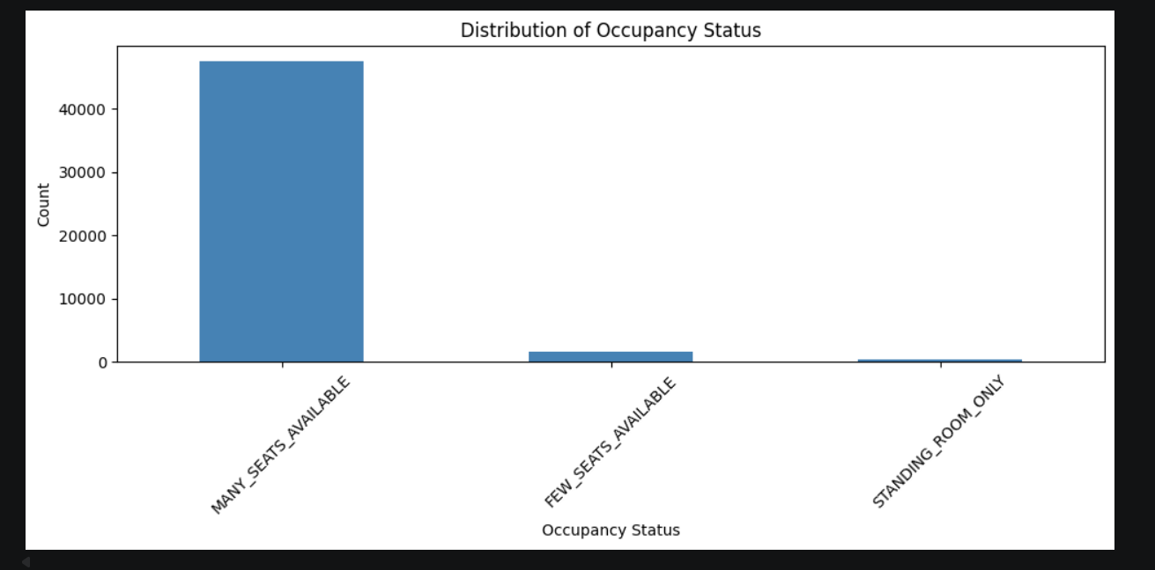
Figure 1: Occupancy Status bar plot against Count

The chart reveals a heavily imbalanced distribution:
- MANY_SEATS_AVAILABLE: ~47,500 services, is the dominant category by a large margin
- FEW_SEATS_AVAILABLE: ~1,581 services, significantly less common
- STANDING_ROOM_ONLY: ~396 services, extremely rare

Insight: NSW trains are overwhelmingly uncrowded. The majority of services have many seats available, indicating that the network is not operating near capacity for most of the day. This class imbalance will be addressed during the Stage 2 modelling.

4.2 Categorical Feature 2 — Segment Direction
A bar chart was used to compare the number of services in each direction of travel since the values were discrete, bar charts make the most suitable option for visualization here.

After removing trailing whitespace, exactly two categories were confirmed:
- Up direction: ~24,939 services
- Down direction: ~24,543 services

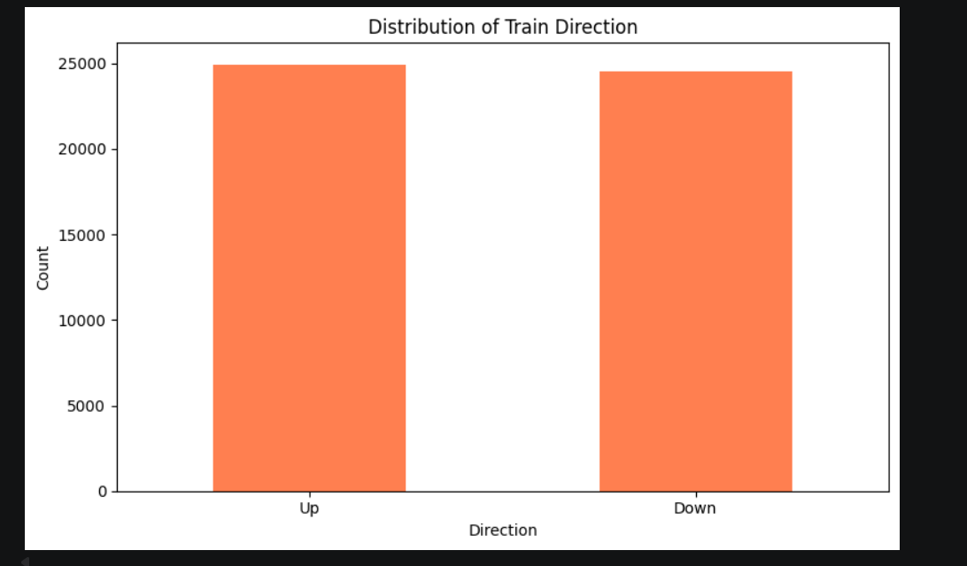

Figure 2: Segment Direction attribute bar graph plotted against Count

Insight: Train services are almost perfectly balanced between Up and Down directions. This is consistent with expectations for a rail network, that is: for every service in one direction, there is a corresponding return service. This balance also indicates that there are no directional biases in the data.

4.3 Numerical Feature 1: Node Sequence Order
A histogram was used to visualize the distribution of Node.Seq.Order, which represents the position of a station within a route (stop 1 being the first stop, stop 35 being the last on the longest routes).

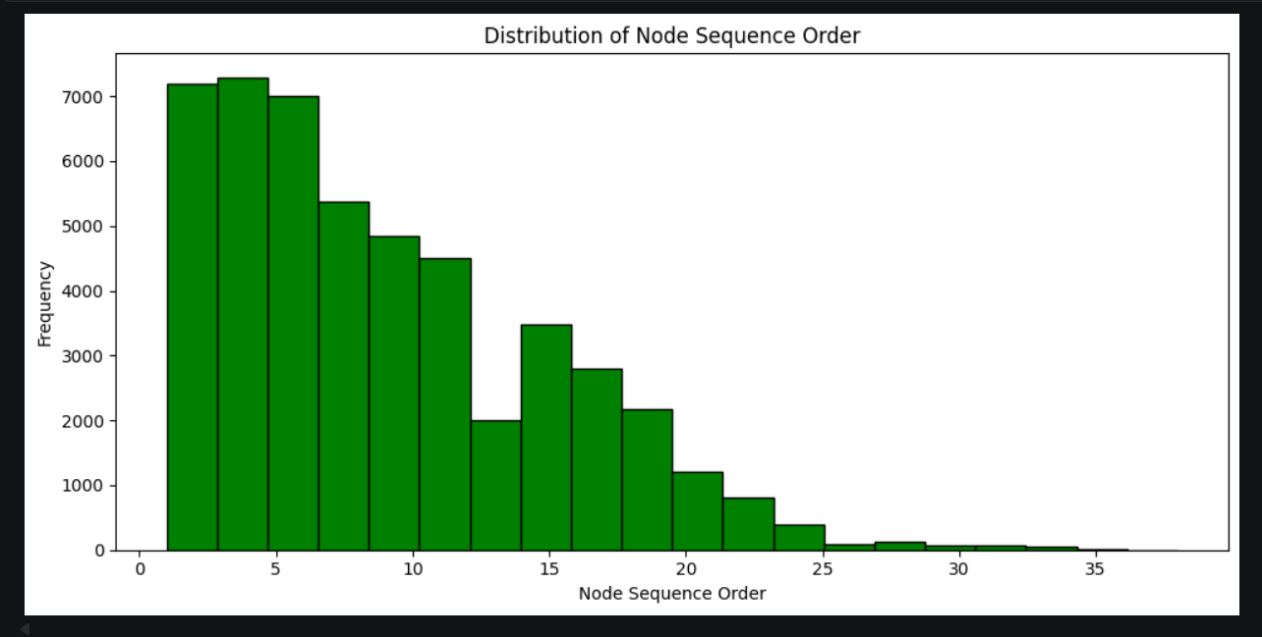
Figure 3: Distribution of Node Sequence Order — frequency of observations per stop position
- Stop 1 has the highest frequency, every route starts here, so all services contribute a record at stop 1.
- Frequency decreases as stop number increases, only longer routes reach higher stop numbers.
- Very few observations exist beyond stop 15, indicating that most NSW train routes have fewer than 15 stops.

Insight: Most train services in NSW have fewer than 15 stops, with stop position frequency decreasing as sequence order increases, suggesting that longer routes are less common in the train network. This feature is relevant to the research question as occupancy may increase along a route as passengers board.

4.4 Numerical Feature 2: Day

Carried out process: Initially a histogram was used to visualize the train services assuming that the day attribute in the dataset represented days of the week instead of calendar dates over the span of 8 days from day 9 to day 16.

Hence, a bar chart was used to visualize the number of train services recorded per calendar day, providing a clearer view than a histogram given the discrete nature of the day values.

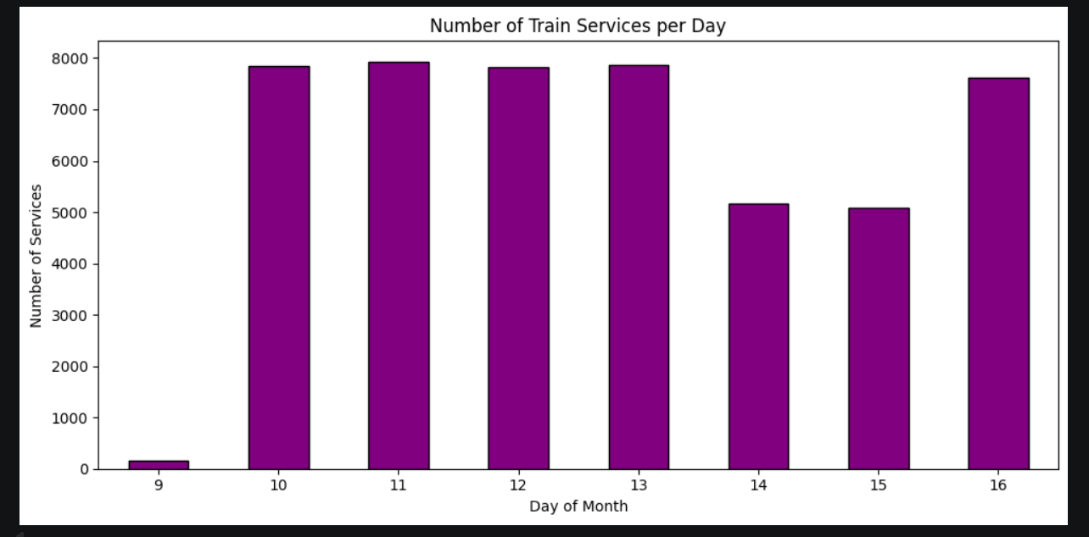
Figure 4: Number of train services recorded per calendar day (days 9–16)

- Day 9: Very few services were recorded assuming the data collection had just started.
- Days 10–13: Consistently ~8,000 services each weekday operations were observed.
- Day 14: ~5,000 services, consistent with a Saturday (fewer commuter services).
- Days 15–16: Combined ~12,500 services covering Sunday and the return to Monday.

Insight: The day column represents calendar dates rather than day-of-week numbers. The dataset spans 8 days of train service records. Weekday services (days 10 to 13, 16) averaged approximately 7,900 train services per day, while weekend services (days 14 to 15) averaged only 5,100, implying about 35% fewer services on weekends, reflecting lower commuter demand.

4.5 Correlation Between Numerical Features
A correlation matrix was computed between the two numerical features: day and Node.Seq.Order, to assess any linear relationship between them.

Feature Pair | Pearson Correlation | Interpretation
day vs Node.Seq.Order | -0.009 | Virtually no linear relationship
day vs day | 1.000 | Perfect self-correlation (expected)
Node.Seq.Order vs Node.Seq.Order | 1.000 | Perfect self-correlation (expected)

Insight: The correlation between day and Node.Seq.Order is -0.009, indicating virtually no linear relationship between the calendar day and station sequence order. This is expected as the route structure of a train does not change based on the calendar day. These two features are therefore independent and can both be used as input features in Stage 2 modelling without multicollinearity concerns.

4.6 Summary of EDA Findings
Feature | Type | Key Finding
Occupancy Status | Categorical | Heavily imbalanced: approximately 95%+ of services have many seats available, crowding is rare.
Segment.Direction | Categorical | Perfectly balanced between Up and Down, no directional bias was seen in the dataset.
Node.Seq.Order | Numerical | Most routes have fewer than 15 stops; longer routes are less common which is to be expected.
day | Numerical | Weekdays have ~35% more services than weekends, according to the dataset record span of 8 days.
day vs Node.Seq.Order | Correlation | Correlation of -0.009, features are independent; no multicollinearity concerns for stage 2 modelling.

Dataset B: Air Travel Delay

Step 1. Problem Definition

1.1 Business Problem
One of most expensive and disruptive issues in commercial aviation is flight delays. Every year, aircraft delays cost the US airline industry billions of dollars due to higher fuel consumption, personnel overtime, gate disputes and passenger compensation. The following regression problem is defined by this analysis:

“Can we predict the arrival delay (in minutes) of a commercial flight, given information available at or before the time of departure?”

The goal variable in this regression problem is ArrDelay or the amount of time a flight is delayed in relation to its scheduled arrival time. Early arrivals are indicated by negative values. Predictive features that are known at or soon after departure include departure delay, scheduled departure time, carrier, origin and destination airports, day of the week, distance and taxi-out time.

1.2 Why Regression?
Although it is easier, a binary classification method (delayed vs. not delayed) ignores important information. Despite the operational differences between a flight that arrives 6 minutes late and one that arrives 4 hours late, a classifier treats them the same. The algorithm generates granular, actionable outputs that are directly helpful for operational decision making by forecasting the precise delay in minutes.

1.3 Stakeholders and Benefits
Stakeholder | Benefit from Solving the Problem
Airlines (Southwest, ExpressJet) | Proactively manage crew scheduling, gate reassignments and fuel planning when a delay is predicted. Reduces cascading delays across the network.
Airport Operations Teams | Allocate ground crew, gates and baggage handling resources more efficiently based on predicted arrival times.
Passengers | Receive earlier and more accurate delay notification, allowing them to rebook connections and adjust plans.
Air Traffic Control | Anticipate congestion at destination airports and adjust sequencing and holding patterns proactively.
Travel Booking Platforms | Surface real-time delay risk estimates to users at the time of booking or check-in, improving customer experience.

Step 2. Data Description

2.1 Dataset Overview
Each row in the dataset represented a single commercial flight between two US airports in January 2008. The 29 attributes covered five broad categories: temporal information (date and scheduled times), airlines information (carrier and flight identifiers), route information (origin and destination airports), delay information (departure and arrival delays), operational data (distance, cancellations, taxi times).
Property | Value
Total Rows (instances) | 101,000
Total Columns (attributes) | 29
Missing Values | Present (dropped during cleaning)
Duplicate Rows | Present (removed during cleaning)

2.2 Data Types of Each Attribute

The 29 attributes were inspected for their stored data type. Fourteen columns were correctly stored as numeric types (int64 and float64). 10 columns that represented numerical values such as time and distance were incorrectly stored as string (object) types. The remaining 5 columns are legitimate categorical attributes.
Attribute | Data Type | Description
ArrDelay | float64 | Arrival delay in minutes
DepDelay | float64 | Departure delay in minutes
UniqueCarrier | str | Airline carrier code
Origin and Dest | str | Origin and Destination airport code
DayOfWeek | Int64 | Day of the week (1=Mon to 7=Sun)
Distance, Cancelled, Diverted | Str (Should be numeric) | Flight distance in miles, whether flight was cancelled (0/1), was diverted (0/1)
DepTime and ArrTime | Str (Should be numeric) | Actual departure and arrival time (HHMM format)
CRSDepTime | Str (Should be numeric) | Scheduled departure time (HHMM format)
Year, Month, DayofMonth, FlightNum | Int64 | Which year, specific month, day of the month, each flight’s number
TaxiIn, TaxiOut, CarrierDelay, WeatherDelay, NASDelay, SecurityDelay, LateAircraftDelay | Float 64 | Taxing time, carrier and weather delays, security delays etc.
TailNum, CancellationCode | str | Flight cancellation code, flight license number
ActualElapsedTime, CRSElapsedTime, CRSArrTime, AirTime | Str (Should be numeric) | Elapsed time, flight air time etc.

2.3 Missing Values and Duplicates
Missing values were identified across 15 of the 29 columns. The remaining 14 columns were complete with no missing values. The table below summarises the missing value count and percentage for all affected columns:
Column | Missing Count | Missing Percentage
CancellationCode | 99,364 | 98.38%
CarrierDelay, WeatherDelay, NASDelay, SecurityDelay, LateAircraftDelay | 81,177 | 80.37%
TailNum | 4,146 | 4.11%
ArrDelay | 3,300 | 3.27%
DepDelay | 3,150 | 3.12%
ArrTime | 1,281 | 1.27%
DepTime | 1,127 | 1.12%
TaxiIn | 2,311 | 2.29%
TaxiOut | 2,153 | 2.13%
ActualElapsedTime, AirTime | 1,310 | 1.30%

The high missing values in CancellationCode and the five delay cause columns is not a data error but a natural property of the dataset as these fields are only recorded when cancellation or delay actually occurs. All the missing values are addressed appropriately in the data cleaning step.

2.4 Unique Values in Categorical Features
Fifteen columns were identified as categorical which were further classified by the concept of cardinality (the number of unique values they contain). The low cardinality columns (15 or fewer unique values, the number 15 was chosen at random as a lot of values were observed to be below it) were inspected in detail as they seemed most relevant for modelling and revealed several data issues and which were later resolved in data cleaning step.
Column | Unique | Missing Actual Values / Notes
CancellationCode | 3 | A (Carrier), B (Weather), C (NAS) - Clean
Cancelled | 6 | '0', '1', 'TRUE', 'FALSE', 'Y', 'N' - Mixed encoding, needs fixing
Diverted | 6 | '0', '1', 'TRUE', 'FALSE', 'Y', 'N' - Mixed encoding, needs fixing
UniqueCarrier | 10 | 'WN', 'wn', ' WN', 'WN ', 'XE', 'xe', ' XE', 'XE ', 'W', 'X' - Mixed case and spaces, needs fixing
Origin | 308 | High cardinality - 308 unique airport codes
Dest | 312 | High cardinality - 312 unique airport codes

2.5 Unique Values in Categorical Features

Descriptive statistics were computed for all 14 columns to understand their central tendency, spread and range.
Column | Mean | Median | Std Dev | Min | Max | Note
ArrDelay | 5.71 | -2.0 | 30.91 | -57 | 500 | Target variable
DepDelay | 10.37 | 1.0 | 28.34 | -44 | 516 | Key predictor
Distance | 627.7 | 451.0 | 441.7 | -2176 | 2363 | Has negatives
TaxiOut | 10.93 | 9.0 | 5.99 | 1 | 150 | Clean
TaxiIn | 4.77 | 4.0 | 2.98 | 1 | 213 | Clean
AirTime | -- | -- | -- | -- | -- | Has negatives

The negative values in ArrDelay and DepDelay represent early arrivals and departures which are valid and expected. However, negative value in Distance and AirTime are Physically impossible and probably represent a data recording error, which are further addressed in the cleaning step.

Step 3. Data Cleaning and Processing

Data cleaning is the process of detecting and correcting errors, inconsistencies and inaccuracies in the dataset to ensure it is accurate, consistent and ready for modelling. The following data quality issues were identified in step 2 and addressed in this step.

3.1 Fixing Incorrect Data Types
Ten columns were identified as being stored in incorrect data types, the numerical values were stored as strings. These columns included time columns (DepTime, CRSDepTime, ArrTime, CRSArrTime), duration columns (ActualElapsedTime, CRSElapsedTime, AirTime), Distance, Diverted and Cancelled. If kept as strings they were hindering the mathematical operations, statistical analysis and could have caused issues with the modelling. All these columns were converted to numeric using a coerce strategy in which any value that could not be converted was replaced with NaN rather than causing an error, ensuring the conversion was safe and handled any hidden dirty values automatically.
Column | Type Before | Type After Conversion
DepTime | str | float64
CRSDepTime | str | float64
ArrTime | str | float64
CRSArrTime | str | float64
ActualElapsedTime | str | float64
CRSElapsedTime | str | float64
AirTime | str | float64
Distance | str | float64
Cancelled | str | float64
Diverted | str | float64

3.2 Standardising Inconsistent Values
Going further three columns contained inconsistent value encoding, they basically had different representations of the same categories, which could have caused them to be treated as multiple different categories by a model, leading to incorrect analysis and poor performance.

For the Cancelled and Diverted Columns, we already converted their values to numeric (0.0/1.0), now we simply filled the NaN values with 0 to simply and converted them to int data type, hence making them clean integers (0/1).
While for UniqueCarrier we first removed whitespaces and made everything capitalized then the mapping of partial and corrupted code to correct carrier code was done, the table below gives the summary of what changes were done.
Column | Issue | Fix Applied | Before | After
Cancelled | Mixed encoding: 0/1/TRUE/FALSE/Y/N | Filled NaN with 0, converted to integer | 3 | 2
Diverted | Mixed encoding: 0/1/TRUE/FALSE/Y/N | Filled NaN with 0, converted to integer | 3 | 2
UniqueCarrier | Mixed case, spaces, partial codes (W, X) | Stripped spaces, uppercased, mapped W->WN and X->XE | 10 | 2

3.3 Handling Invalid Entries

Four columns were found to contain physically impossible negative values being, Distance, ActualElapsedTime, CRSElapsedTime and AirTime.a flight cannot have a negative distance value, elapsed or air time. These clearly seemed like data recording errors.

For strategy, all rows containing a negative value in any of these four columns were removed. It only accounted for around 1% of the dataset. A total of 1009 rows were removed, the table below shows how much each column had.
Column | Negative Count | Percentage
Distance | 248 | 0.25%
ActualElapsedTime | 234 | 0.23%
CRSElapsedTime | 273 | 0.27%
AirTime | 256 | 0.25%

3.4 Handling Missing Values

After the previous cleaning steps, 19 columns still had missing values. After a bit self-analysis three strategies were applied based on the nature and meaning of each column.

Strategy 1 - Dropping Columns Entirely

Two columns were dropped entirely, CancellationCode had around 98% missing values and only populated data of cancelled flights, making is useless for predating arrival delay, TailNum is the aircraft registration number with has no predictive value for delay.

Strategy 2 – Filling with 0

The five delay columns were filled with 0, as these columns are only recorded when a delay actually occurs, a missing value basically means the flight had 0 delay from that cause, so filling them with 0.

Strategy 3a – Dropping some rows

Rows where ArrDelay values were missing were dropped as it is the target variable and cannot be estimated or filled. Rows where ArrTime or DepTime were missing were also dropped, as these missing values indicated cancelled or diverted flights whose records are unreliable for modelling.

Strategy 3b – Filling with median

Nine remaining columns with small proportions of missing values were filled with their respective median values. Median was preferred over mean as it is robust to the outliers known to exist in delay and time columns. The columns filled were: DepDelay, TaxiIn, TaxiOut, ActualElapsedTime, AirTime, Distance, CRSElapsedTime, CRSDepTime, and CRSArrTime.

Strategy | Action | Columns Affected | Rows Affected
1. Dropping Column | Removed 2 columns | CancellationCode, TailNum | None
2. Filling with 0 | Filled 5 columns | 5 delay cause columns | None
3a. Dropping Rows | Removed rows with missing ArrDelay, ArrTime, DepTime | ArrDelay, ArrTime, DepTime | 5,570 rows dropped
3b. Filling with Median | Filled 9 columns with median | DepDelay, TaxiIn, TaxiOut, AirTime, Distance and others | None

3.5 Dropping Redundant or Irrelevant Features

Seven columns were identified as redundant or irrelevant and were removed from the dataset.
Column | Justification for Removal
Year | Only 1 unique value (2008) which is constant across all rows, adds zero information to any model.
Month | Only 1 unique value (January) also constant across all rows, adds zero information.
Diverted | Only 1 unique value (0) after row cleaning, all diverted flights were removed when rows with missing ArrTime were dropped.
FlightNum | Flight number assigned by the airline having no real predictive meaning for arrival delay.
Cancelled | After dropping rows with missing ArrDelay and actual times, this column adds no useful signal to the remaining dataset.
DepTime | Actual departure time recorded after the flight has departed but is not available at prediction time. Including it would cause data leakage.
ArrTime | Actual arrival time recorded after the flight has landed again not available at prediction time. Including it would also cause data leakage.

.

3.6 Feature Engineering

Five new features were created from existing columns to better capture patterns relevant to predicting arrival delay.
Feature | Derived From | Method | Rationale
DepHour | CRSDepTime | Floor (CRSDepTime / 100) | CRSDepTime is in HHMM format. Extracting the hour captures the strong time-of-day delay pattern, 6am flights average -3.3 min, 9pm flights average +15 min.
IsWeekend | DayOfWeek | 1 if Day in {6,7} else 0 | Weekend flights average 7.42 min delay vs 5.13 min on weekdays. A binary flag cleanly captures this pattern.
Route | Origin + Dest | Concatenate Origin and Dest | Specific route combinations have distinct delay profiles (e.g. LAS->SFO averages +42 min). Neither column alone captures this.
BufferTime | ActualElapsedTime, AirTime, TaxiIn, TaxiOut | ElapsedTime - AirTime - TaxiIn - TaxiOut | Captures unaccounted operational time beyond flying and taxi, being a potential signal for ground congestion and scheduling inefficiency.
DelayCategory | ArrDelay | Binned: Early / On Time / Minor / Major / Severe | Converts the continuous ArrDelay into interpretable categories. 55% Early, 23% Minor, 14% Major, 4.7% Severe.

3.7 Cleaning Summary
Metric | Value
Original Dataset Size | 101,000 rows x 29 columns
Rows Removed (Invalid Entries) | 1,009 rows
Rows Removed (Missing Values) | 5,570 rows
Columns Dropped | 9 columns (2 in missing values step + 7 redundant)
New Features Engineered | 5 (DepHour, IsWeekend, Route, BufferTime, DelayCategory)
Final Dataset Size | 94,421 rows x 25 columns
Missing Values Remaining | 0
Data Retained | 93.49%

Step 4. Exploratory Data Analysis
Two numerical features (ArrDelay and DepDelay) and two categorical features (UniqueCarrier and DayOfWeek) were selected for Analysis. These four features were chosen as they came across as directly relevant to the research question of understanding and predicting flight arrival delays.

4.1 Numerical Feature 1: ArrDelay (Arrival Delay)
For this feature a histogram was chosen as the appropriate method for a continuous numerical variable as it revealed the full distribution shape, skewness and outliers.
Statistic | Value
Count | 94,421 flights
Mean | 5.69 minutes
Median (50th) | -2.00 minutes
Std Deviation | 30.88 minutes
Min | -57.00 minutes
Max | 500.00 minutes
Skewness | 4.0255
Kurtosis | 25.9626

Delay Category Breakdown:
Category | Count | Percentage
Early (< 0 min) | 51,966 | 55.04%
On Time (= 0 min) | 2,704 | 2.86%
Minor Delay (1-15 min) | 21,800 | 23.09%
Major Delay (16-60 min) | 13,523 | 14.32%
Severe Delay (> 60 min) | 4,428 | 4.69%

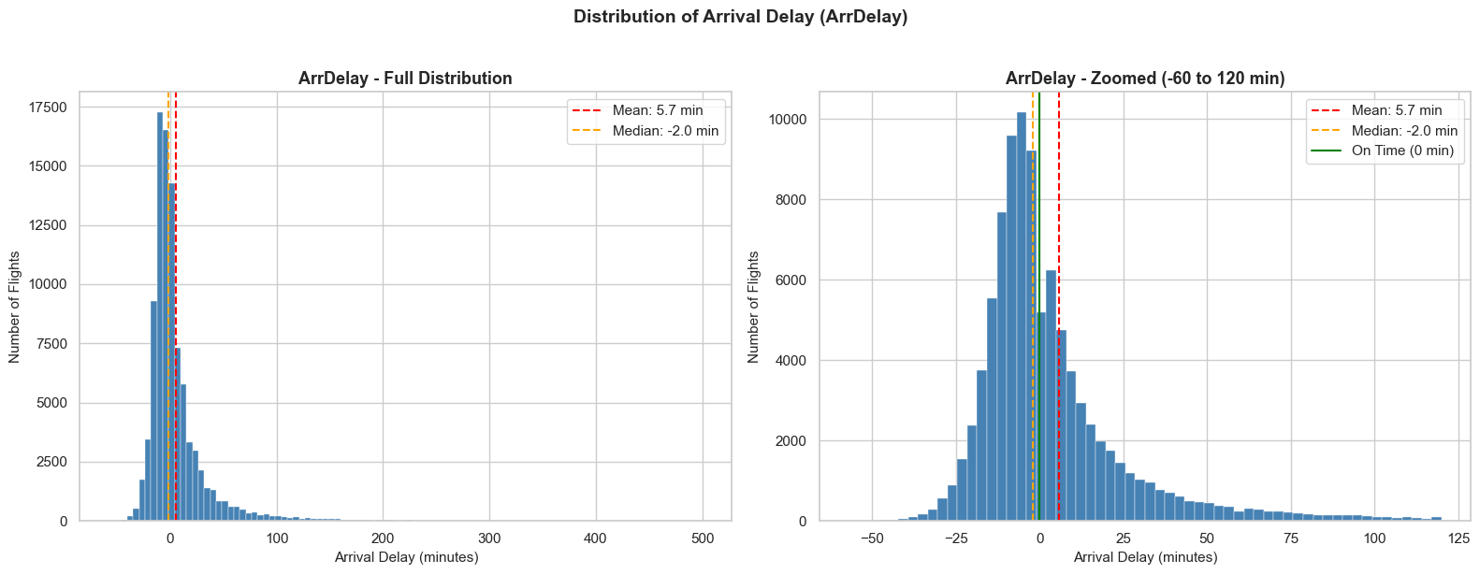
Figure 1: Distribution of Arrival Delay - Full and Zoomed plots
The ArrDelay distribution indicates that most planes arrive on time or early, with a median of 2.0 minutes, despite a mean arrival delay of 5.69 minutes due to long delays. The skews and kurtosis (4.03 and 25.96) highlight the presence of severe outliers, such as delays caused by weather or equipment issues. The regression model must then account for these outliers, as the delays presented range from -57 to 500 minutes.

4.2 Numerical Feature 2: DepDelay (Departure Delay)
This being the strongest predictor for arrival delay in this dataset, 3 methods were used for visual illustration. A histogram to understand distribution, Pearson correlation to quantify the linear relationship with ArrDelay and a scatter plot with a linear regression line.
Statistic | Value
Count | 94,421 flights
Mean | 10.11 minutes
Median (50th) | 1.00 minute
Std Deviation | 27.86 minutes
Min | -44.00 minutes
Max | 516.00 minutes
Skewness | 4.6891
Pearson Correlation (r) | 0.9298
R-Squared (r²) | 0.8646
Regression Line | ArrDelay = 1.0332 x DepDelay + (-4.7945)


Figure 2: Distribution of Departure Delay
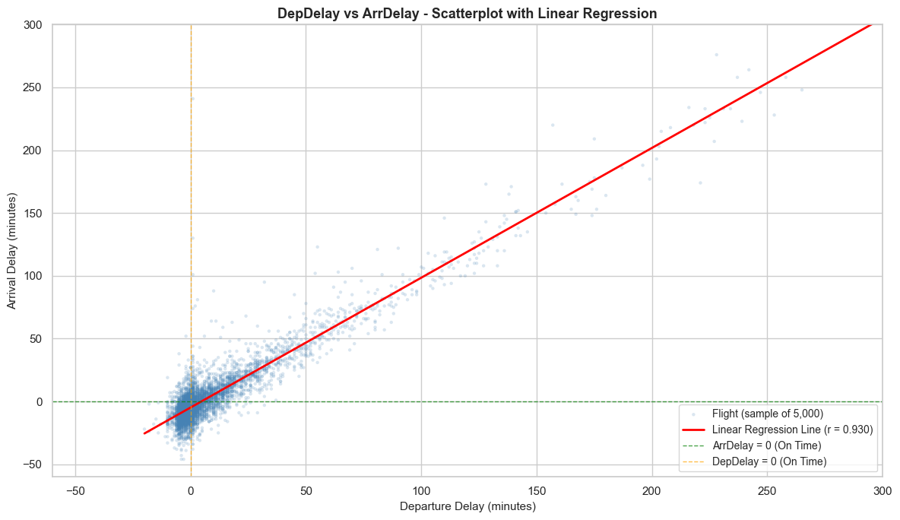
Figure 3: DepDelay vs ArrDelay scatterplot with regression line
During initial data exploration, the Pearson correlation between DepDelay and ArrDelay was 0.942 in the raw dataset of 101,000 rows. After cleaning, the correlation in the final dataset of 94,421 rows dropped to 0.9298, which is a more reliable measure as the cleaning process
Eliminated extreme records that could skew results.
DepDelay exhibits a strong right skewness, indicating that most flights either depart on time or slightly early, with a notable range of severely delayed departures. It has strong positive correlation with ArrDelay, explaining the variance (R²). The scatterplot reveals that flights that depart on time generally arrive on time.

4.3 Categorical Feature 1: UniqueCarrier (Airline Carrier)
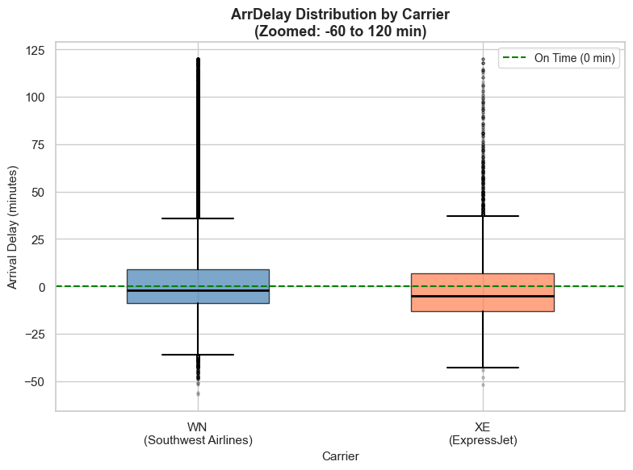
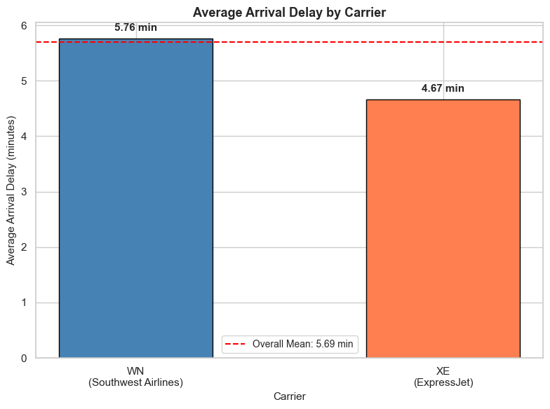
The dataset had two major airline carriers, WN (Southwest Airlines) or XE(ExpressJet), so a bar plot was used to compare average ArrDelay between the two and box plot to show full distribution which included outliers to get a richer picture.
Carrier | Flight Count | Proportion | Mean Delay | Median Delay | Std Dev
WN (Southwest Airlines) | 88,827 | 94.08% | 5.76 min | -2.0 min | 30.38
XE (ExpressJet) | 5,594 | 5.92% | 4.67 min | -4.0 min | 37.89

Figure 4: Average Arrival Delay by Carrier and Box plot ArrDelay Distribution by Carrier
Southwest Airlines (WN) runs 94.08% of the flights in the dataset, which has an effect on overall performance statistics, has a mean arrival of 5.76 minutes compared to ExpressJet’s 4.67 minutes. From the box plot we came to know that both have similar median delays which means early arrivals, but ExpressJEt has a higher standard Deviation, which means that delays are more likely to vary.

4.4 Categorical Feature 2: DayOfWeek
This feature captures the day of the week on which a flight operates (1 = Monday through 7 = Sunday). Business travel peaks on certain days, leisure travel on others. Two bar plot were used, one used to compare average ArrDelay across all seven days and the other to show flight counts per day.
Day | Flight Count | Mean Delay | Median Delay | Std Dev
Monday (1) | 13,734 | 4.51 min | -3.0 min | 29.11
Tuesday (2) | 13,869 | 0.45 min | -4.0 min | 21.68
Wednesday (3) | 13,902 | -1.62 min | -5.0 min | 18.55
Thursday (4) | 16,050 | 13.36 min | 2.0 min | 38.42
Friday (5) | 13,678 | 7.70 min | 0.0 min | 28.17
Saturday (6) | 10,696 | 1.99 min | -4.0 min | 27.30
Sunday (7) | 12,492 | 12.07 min | -0.5 min | 41.77
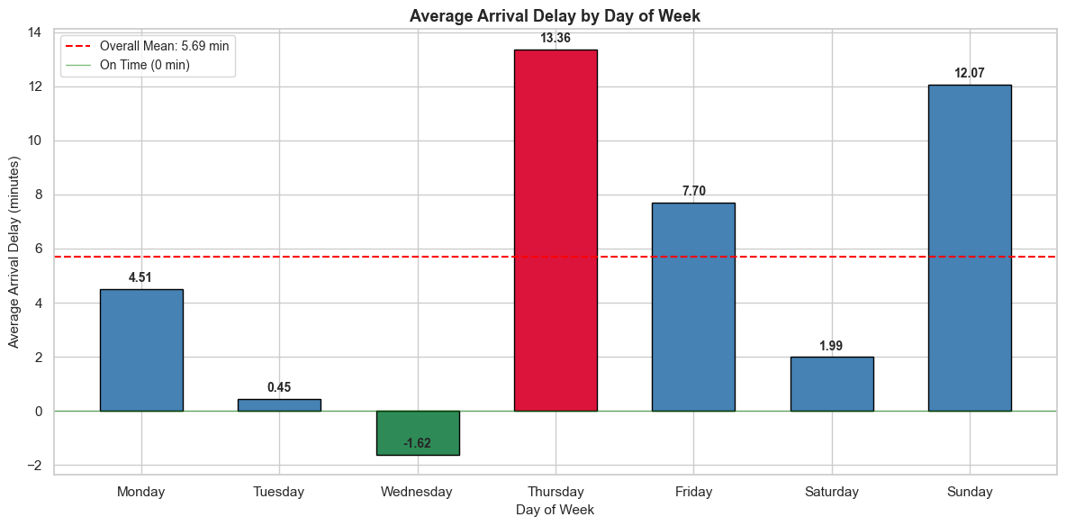
Figure 5: Average Arrival Delay by Day of Week
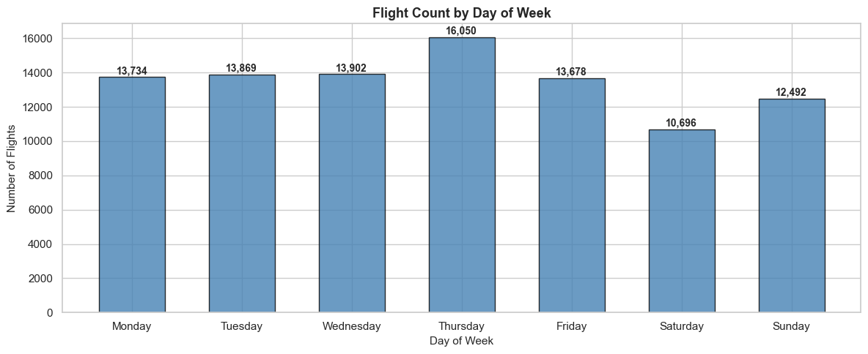
Figure 6: Flight count by Day of Week
Thursday has the worst arrival delays, with an average of 13.36 minutes, while Wednesday has the best, with an average of -1.62 minutes. This shows that the day of week has a big effect on delays. With 16,050 flights, Thursday is the busiest travel day, which causes traffic jams and delays that spread. Sunday has the second longest average delay, 12.07 minutes, because people who are on vacation are coming back. Tuesdays and Wednesdays are days with fewest delays because there is less air traffic. The differences seen between days gives us useful information for future regression models.

4.6 Summary of EDA Findings
Feature | Key Finding | Implication for Modelling
ArrDelay | Strongly right-skewed (skewness = 4.03), median = -2 min, max = 500 min | Target variable has extreme outliers; model must be robust to skewness
DepDelay | Pearson r = 0.9298, R² = 0.8646, slope = 1.03 min per min | Strongest single predictor, most influential feature in future model
UniqueCarrier | WN averages 5.76 min vs XE at 4.67 min. XE has higher variability (Std Dev 37.89 vs 30.38) | Carrier identity adds signal beyond delay magnitude which captures operational variability
DayOfWeek | Thursday worst (13.36 min), Wednesday best (-1.62 min) with a 14.98 min gap | Strong day-level signal, DayOfWeek and IsWeekend should both be included

Dataset C: Hotel Booking

Step 1. Problem Definition

1.1 Business Problem
Hotel chains/ owners manage thousands of reservations across the city and resort properties. The main challenge faced by the operations and financial team is to know whether the customer will cancel their booking before arriving. This analysis defines the following classification problem:
“Can we predict whether a hotel booking will be canceled before the guest’s arrival, using the information available at the time of booking?”

1.2 Stakeholders and Benefits
Stakeholder | Benefit from Solving the Problem
Hotel Finance Team | Use cancellation predictions to remove overbooking levels dynamically, rather than applying policies on booking cancelation.
Operation and Front of House Teams | More accurate arrival forecasts will help in planning staffing and room readiness
Online Travel Agencies | Can define better commission structure or insurance policy based on the knowledge at the time of booking
Guests | Benefits from fair pricing of rooms.

1.3 Problem Type
The target variable is is_canceled (1 = cancelled, 0 = not cancelled), making this a binary classification task. With a cancellation rate of approximately 37% observed in this dataset, the financial stakes are significant.

Step 2. Data Description

2.1 Dataset Overview
The Hotel Booking dataset was loaded and inspected to understand its structure and content before any cleaning was applied to the dataset.

Property | Value
Total Rows (instances) | 119987
Total Columns (attributes) | 32
Missing Values | Present (dropped during cleaning)
Duplicate Rows | Present (removed during cleaning)

2.2 Data Types of Each Attribute

Booking Information
Feature | Type | Missing | Description
hotel | string | 0% | Hotel type — City Hotel or Resort Hotel
is_canceled | int | 0% | Target variable — 1 if cancelled, 0 not cancelled
lead_time | int | 0% | Days between booking date and arrival date
booking_changes | int | 0% | Number of changes made before check-in
deposit_type | string | 0% | Deposit policy — No Deposit, Non Refund, Refundable
days_in_waiting_list | int | 0% | Days on waitlist before confirmation
reservation_status | string | 0% | Final status — Check-Out, Cancelled, No-Show (drop before modelling)
reservation_status_date | date | 0% | Date the reservation status was last set

Arrival Details
Feature | Type | Missing | Description
arrival_date_year | int | 0% | Year of arrival
arrival_date_month | string | 0% | Month of arrival — full name
arrival_date_week_number | int | 0% | Week number of arrival
arrival_date_day_of_month | int | 0% | Day of the month of arrival
stay_in_weekend_nights | Int | 0% | Number of weekend nights
stay_in_week_nights | Int | 0% | Number of weekday nights

Customer Characteristics
Feature | Type | Missing | Description
adults | int | 0% | Number of adults in the booking
children | float | 0.15% | Number of children stored as float, should be integer
babies | int | 0% | Number of babies in the booking
country | string | 0.52% | Guest country of origin
is_repeated_guest | int | 0% | 1 if guest has previously stayed at the hotel
previous_cancellations | int | 0% | Number of prior bookings the guest cancelled
previous_bookings_not_canceled | int | 0% | Number of prior bookings completed without cancelling
customer_type | string | 0.13% | Transient, Transient-Party, Contract, or Group

Market Segments
Feature | Type | Missing | Description
market_segment | string | 0.11% | Segment the booking came from
distribution_channel | string | 0.14% | Channel used to distribute the booking
agent | float | 13.79% | Travel agency ID
company | float | 94.31% | Company ID

Operational and Financial Indicator
Feature | Type | Missing | Description
meal | string | 0.12% | Meal plan chosen
reserved_room_type | string | 0% | Room type requested at booking
assigned_room_type | string | 0% | Room type actually assigned at check-in
required_car_parking_spaces | int | 0% | Number of parking spaces requested
total_of_special_requests | int | 0% | Total number of special requests made
adr | float | 0% | Average Daily Rate — total revenue ÷ total nights

2.3 Missing Values and Duplicates
During inspection of the data, company attribute was dropped as more than 90% of data was missing and duplicate rows were dropped, rest of the missing values were handled using 0 or unknown based on the attribute.

Issue | Finding | Action Taken
Missing Values | Majorly present in company columns | Company column is dropped and same missing values replaced with 0 or “Unknown”
Duplicate Rows | Duplicate entries detected | Removed

2.4 Unique Values in Categorical Features
Key categorical columns were inspected for unique values. This revealed data quality issues that are addressed in Step 3:
- Hotel: Data inconstancies were present ['City Hotel', 'Resort Hotel', 'ResortHotel', 'CityHotel'] converted to [‘City Hotel’, ‘Resort Hotel’].
- Arrival_Date_Month: Included the different month like January, February, December.
- Meal: Different meal plans were present [“BB”, “HB”, “SC”, “FB”, “Undefined”, “nan”]. Missing values(nan) were replaced with SC as it meant opted out of meal plan.
- Market_Segment: Included values like [“Online TA”, “Groups”, “Direct”, “Complementary”]
- Reserved_Room_Type: ['A', 'D', 'E', 'H', 'F', 'C', 'G', 'B', 'P', 'L']
- Deposit_Type: [“Refundable”, “Non-Refundable”, “No Deposit”]
- Customer_Type: [“Transient”, “Group”, “Contract”, “Transient-Party”]

Step 3. Data Cleaning and Processing

3.1 Issues Identified and Cleaning Strategies
The following data quality issues were identified and resolved using data cleaning strategies.

Issue | Column Affected | Cleaning Strategy | Justification
Missing values | Company, children, agent, country, meal, market_segment, customer_type, distribution_channel, | Dropped column Company  Filled missing values in numerical data with 0  Filled missing values in categorical data with “Unknown”. For meal filled missing data with “SC” considering guest opted out of meal | Since not much data was missing if was handled appropriately and company column was dropped as more than 90% data was missing.
Duplicate rows | Entire dataset | Removed using df.drop_duplicates() | Duplicates would skew frequency counts and introduce bias in EDA and modelling.
Inconsistent capitalization | Meal, market_segment, distribution_channel, customer_type, reservation_status | Standardised to uppercase. | Ensures consistent category labels for grouping and visualization.
Typographical error | Market_segment, | Replaced to correct value using replace() | Corrects the label to match the valid category.
Whitespace inconsistency and Trailing Whitespace | Hotel, meal, market_segment, customer_type | Removed spaces after some categories and some values needed space in between. | Trailing spaces values to appear as more distinct categories.

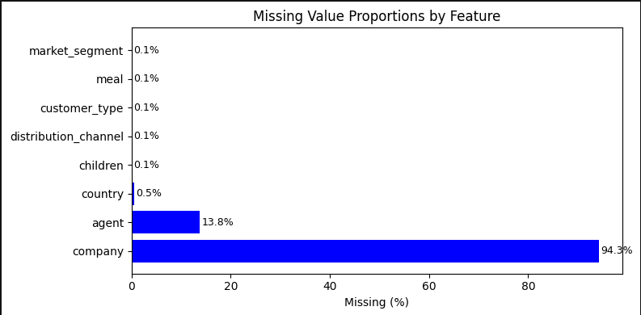
Figure 1: Missing values % graph.

Insight on missing and duplicate values: Upon thorough inspection of the dataset, the company column was dropped, rest of the missing values were filled with there related meanings like for numerical it was filled with 0 and for categorical we can take example of meal which was filled with SC.

3.2 Data After Cleaning
After applying all cleaning processes, the dataset of shape(74111, 31) was verified and saved as hotel_analysis_cleaned.csv. The final cleaned dataset had no missing values, no duplicate rows, and ready for EDA.

3.3 Feature Engineering

Three new features were created to help the model to better predict the cancelation of bookings:
Feature | Derived From | Method | Rationale
total_guests | Children, adults, babies | Children + adult + babies | Created to feed the model with total number of guests.
total_nights | stay_in_weekedn_nights,  stay_in_week_nights | Adding both the columns | Created to get the exact duration of stay
arrival_date | arrival_day_month, arrival_day_year,  arrival_date_day_of_monnth | Converted to  YYYY-MM-DD | Providing the information to the model what is the expected arrival date

Step 4. Exploratory Data Analysis
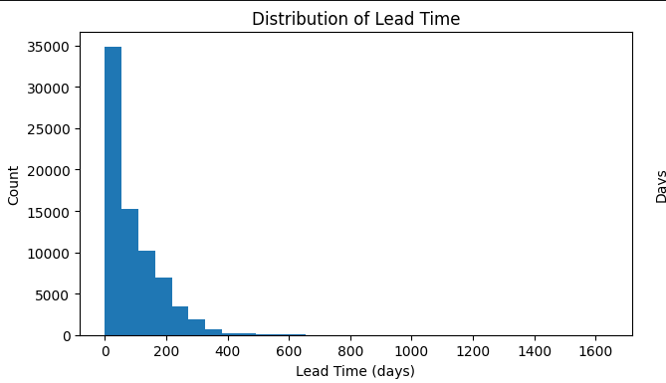
Figure 1: Distribution of Lead Time

From the above histogram we see that the lead time follows a strong right-skewed distribution, with the majority of bookings made within 0-100 days of arrival. The tallest bar (0-50 days) contains approximately 35,000 bookings from this can be interpreted that most guests book close to their arrival date.

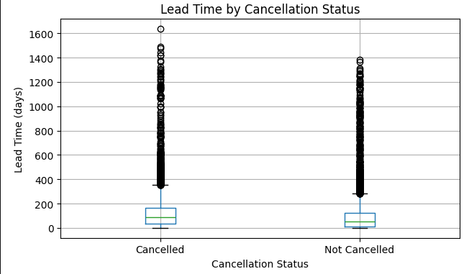
Figure 3: Lead Time by Cancellation Status
From the above figure we can interpretate that cancelled bookings have a noticeably higher median lead time and a wider IQR compared to bookings that were not cancelled. The median for cancelled bookings appears to be around 100–120 days, while not-cancelled bookings sit closer to 50–60 days.

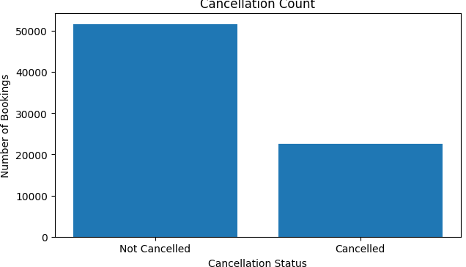

Figure 4: Cancellation Count Graph
The bar chart shows the class distribution of the target variable. Approximately 52,000 bookings were not cancelled compared to around 23,000 that were cancelled. Classes are imbalanced but the minority class is still substantial that normal models could learn from it.

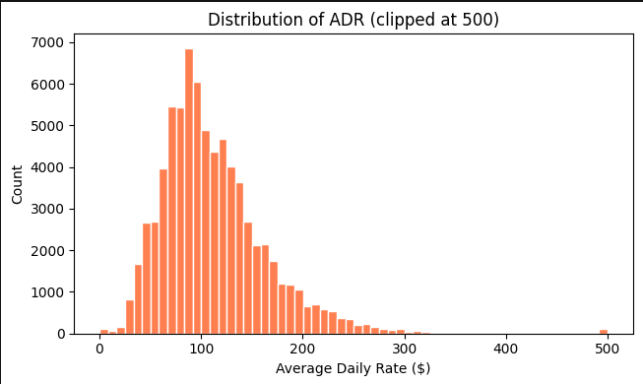

Figure 5: Distribution of ADR.

The above ADR distribution is approximately bell-shaped with a slight right skew. The majority of bookings fall within the $50–$200 range, with the peak occurring around $80–$100 per night.

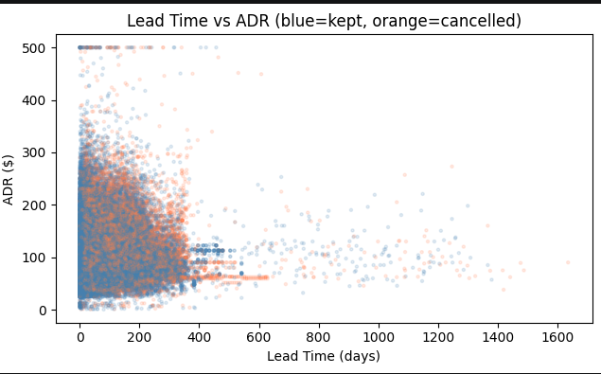

Figure 6: Lead Time vs ADR scatter plot

The above plot shows cancelled bookings as orange and kept bookings as which were not cancelled across the lead time and average daily room rate. The data is concentrated highly in the timespan of (0-300) days and ($0-$200). We can also see that there is no linear relationship between lead time and ADR. We see data scattered all around the graph and can say these two cannot determine the cancelation of bookings.

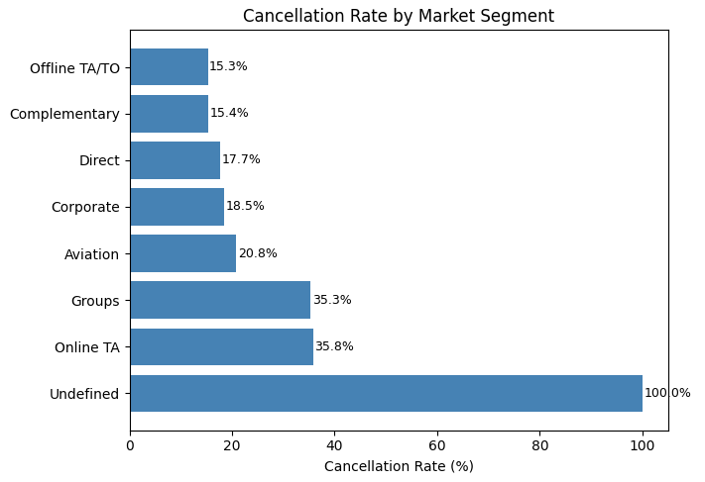

Figure 7: Cancelation Rate by Market Segment

The chart shows cancellation rates vary significantly across segments. Online TA (35.8%) and Groups (35.3%) have the highest rates, while Offline TA/TO (15.3%) and Direct (17.7%) have the lowest. The Undefined segment shows 100% a cancelation rate and will be addressed in further cleaning before modeling.

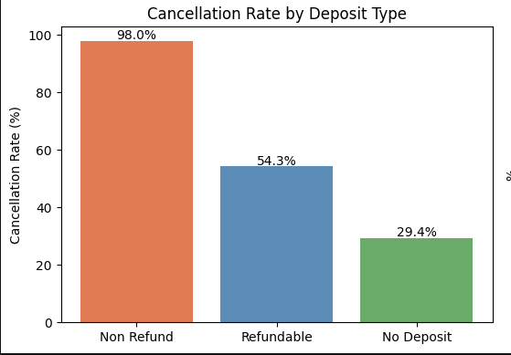

Figure 8: Cancelation of Deposit Time

From the above graph Non-Refund deposits have the highest cancellation rate likely because the reservation status is recorded as cancelled even though the hotel retains the payment.

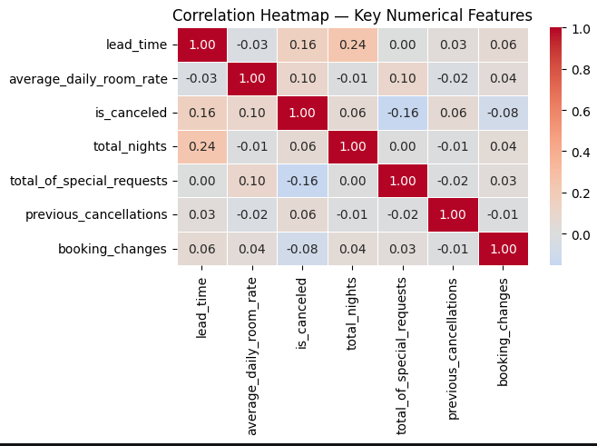

Figure 9: Correlation Matrix

From the correlation matrix above it can be derived that no variable in highly related to each other either positively or negatively. All variables are loosely coupled.

AI ACKNOWLEDGMENT

I used Claude (Anthropic) from 28th March – 2nd April 2026 to assist with structuring the report layout and understanding how to phrase data insights and for some debugging. All code, data analysis, visualizations, cleaning decisions, and final written content are my own. I reviewed, paraphrased, and validated all AI-suggested content before inclusion in this report.

Tool used: Claude (Anthropic)

Dates used: 28th March – 2nd April 2026

How it was used: Assisted with report structure and rephrasing of insights.
My own contribution: All analysis, data cleaning, code, visualizations, and final conclusions are my own.

